**IZTAPALAPA TECHNOLOGICAL INSTITUTE**

COMPUTER SYSTEMS ENGINEERING.

**CHIP-PET** PET PROTECTION

Presents:

Duran Aguilar Laura

Mateos Ramon Rebeca

Ortega Barron Diana

Sergio Antonio Rosas Trinidad

No. of control:

181080392

181080442

181080479

181080399

Internal Advisor:

Abiel Tomás Parra Hernández

MEXICO CITY

1.- Presentation

It is true that placing an identification plate with our telephone number on its collar, and the fact that it has a microchip (an essential factor for it to travel), can help us in case it gets lost, but both solutions are conditioned to someone finding it, and deciding to contact the owner, or going to a veterinarian or security agents so that they can identify it. And to this we must add the possibility of theft, which is not covered in either case.

2.-Justification

Our project aims to make the creation of the chip for pets, the problem has been the loss of pets and abandonment of them, to solve this problem we will create what is a chip in a necklace which is to know if the pet was lost, and also with the profits will give food, water, a home to abandoned pets.

Our limitations would be not having a place to sell the chip and products, which is very expensive the chip, and our scope would be to reuse the pet, among other things to make products of very good quality and best of all will be not to harm the environment.

|  |  |
| --- | --- |
| **EXISTING PROJECTS**   * High prices. * Dog chips do not offer GPS location. * Limited use. * Water resistant. * Few designs and basics. | **CHIP-PET**     * Affordable prices. * The CHIP-SET allows you to know the location of your canine. * Wide use. * Resistant to water, blows, bites and all kinds of sudden movements. * Different designs or can be customized. |

3- Preliminary schedule of activities

Students:

Duran Aguilar Laura

Mateos Ramon Rebeca

Ortega Barron Diana

Sergio Antonio Trinity Roses.

No. of control:

181080392

181080442

181080479

181080399

Career: Computer Systems Engineering

Project name: Pet Protection

Internal advisor: Abiel Tomas Parra Hernandez

Start date: September 2020

Project objective: Raise awareness of pet abandonment

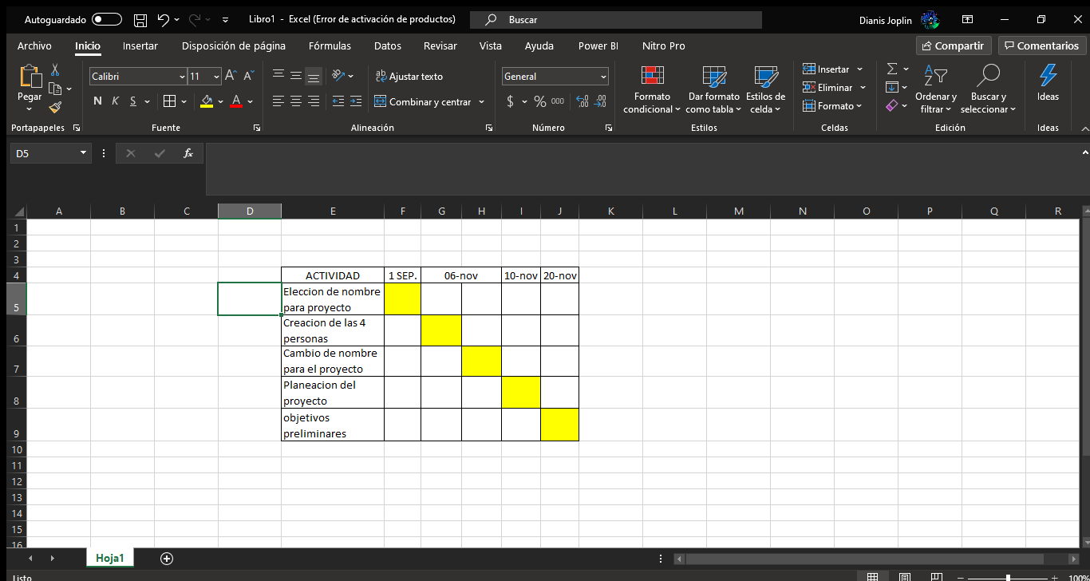

Interviews

PUPIL: Diana Ortega Barron

CONTROL No.: 181080479

* **What is it about?**

♥ This is a GPS chip integrated into a collar for your pet, the use of the chip is to track your pet in real time, which is also safe for rough use as it is but not waterproof.

♥ The chip is also intended to help people with disabilities because it will help people who can use it.

♥ In order to avoid the abandonment of pets and the mistreatment of homeless animals

♥ The CHIP-PET is no longer than 10 cm.

♥ The necklace in which it will be integrated is made of recyclable materials.

♥ The proceeds will be used to help homeless animals, such as food, a home, etc.

1. **Would you pay for such a product?**

p 1-yes

p 2-yes

p 3-yes

p 4-maybe

1. **How much would you pay and why? (Describe the price $)**

p 1-Since animals are like human beings, they must be cared for and protected.

p 2-Considering its use could be $250 or $300 since it is something electronic

p 3- Whatever the price, it is part of the family and it also counts

p 4- More than $1000 but less than $5000, I wouldn't know a fixed price since I don't know how much you have to do to afford it.

Student: Mateos Ramón Rebeca

Control No.: 181080442

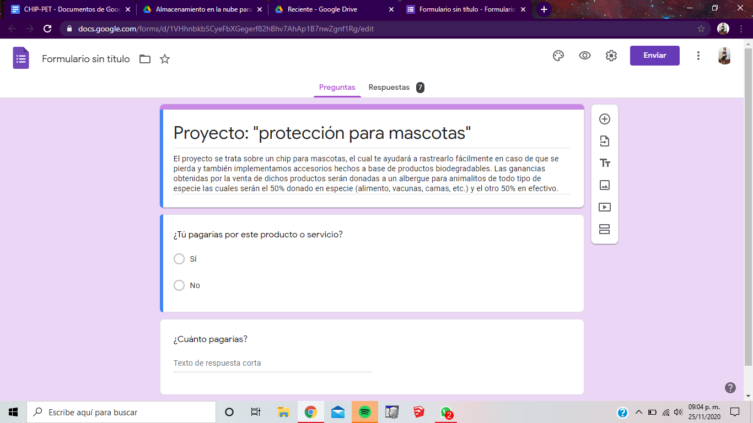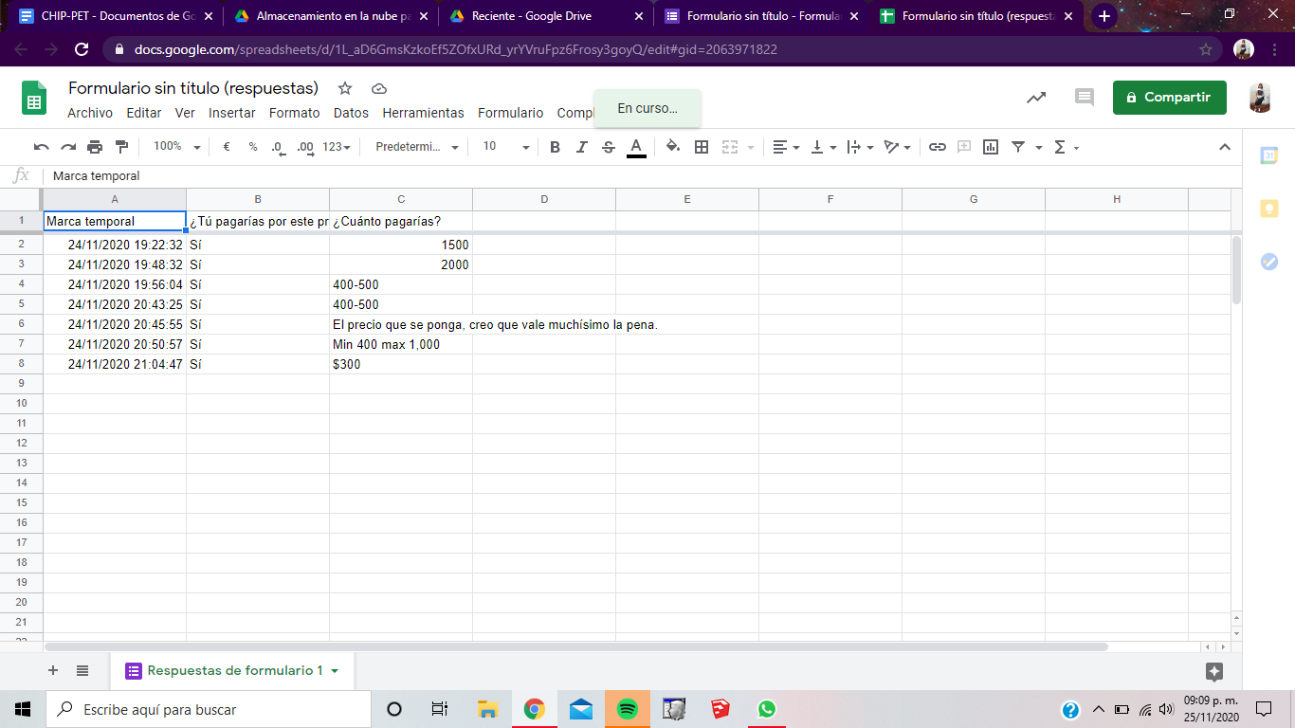

Link: <https://forms.gle/2bhhntZX5oDbeYaN6>

STUDENT: Laura Durán Aguilar

CONTROL No.: 181080392

What is it about?

The project consists of creating a chip

Introduced in the collar for the pet, the function of the chip is to track your pet as it is lost, will also create biodegradable products for pets, this will serve to raise awareness in people to care for your pet, not mistreat the same pet and use biodegradable products not to harm the planet.

The proceeds from the sales of both the chip and the products will be used to buy kibble, vaccines, water and beds for homeless pets.

Would you use it?

A) Si B) No

Person 1: Yes

Person 2: Yes

Person 3: Yes

Person 4: Yes

Person 5: Yes

Would you pay for this service?

A) Si B) Maybe C)No

Person 1: Yes

Person 2: Yes

Person 3: Yes

Person 4: Maybe

Person 5: Yes

How much would you be willing to pay?

Person 1: $ 350

Person 2: $ 800

Person 3: $ 600

Person 4: $ 1000

Person 5: $ 500

Profiles:

Name: Diana Ortega Barron

Control number: 181080479



1. This is Belen Chavez

Pets: 1 cocker dog named toby

Age: 27 years old

From: Veracruz

Lives: In Mexico

Occupation: Laboratory doctor

Marital status: Fiancée

Income: $18,000 per month

Belen is a very busy person during the day, she works in one of the best clinics in Mexico and is director of the wave laboratory department to detect breast cancer. Every day after returning from work she takes Toby for a walk in the park, usually sitting on a bench reading a book while Toby plays in the park with other dogs, her dog is everything to her.



**2) This** is Nahum Vega

Age: 28 years old

Pets: 1 Golden Retriever wendy dog

From: Mexico.

Lives: In Mexico

Occupation: Criminal Lawyer

Marital Status: Single

Income: 10,000 to 12,000 per month

Nahum is a dreamy man and dedicated to his craft, for him the most important thing is his work and his goals, one of his biggest goals is to open a law firm in some state outside of Mexico, he is someone with an open mind without borders. He works quite a bit on projects and that leads him to change his routine constantly. Nahum is the manager of the law firm where he works and although his days are not always the same there is something he respects every morning when he is at home, going out for a run at the racetrack and taking his dog with him.

student: Laura Durán Aguilar

CONTROL No.: 181080392



2. He is Gustavo Trujillo

Pets: 2 puppies of different races, one is called Kiara and the other is called Luna

Age: 25 years old

From: CDMX

Lives: At CDMX

Occupation: Business administrator

Marital status: Single

Income: $12,000 per month

Gustavo is a very happy person during the day, he is working in a business by line right now for the same reason of the pandemic and he also helps his mom with the house and doggie expenses, he takes his little dogs for a walk in the park, in the block of his house, or he takes them to town.

Student: Mateos Ramón Rebeca

Control No.: 181080442



Frida the Coach

Age: 25-28

Gender: Female

Marital status: single

Career: Architecture

Income range: $4000-$5000

Frida is a dog trainer, she likes animals very much, but in particular dogs, she has had several recognitions for her great performance. For this reason, she thought it would be a good idea to place a chip on the pets to make it easier to find them.

Risk Analysis:

|  |  |
| --- | --- |
| List of risks  1. That is not to the liking of the clients.  2. Excessive price.  3. Technical problems with the chip.  4. Secondary problems with pets.  5. Low product sales.  6. Product plagiarism.  7. That we don't have a point of sale.  8. Not getting partners. | Solutions  1. Make several designs and have variety of products.  2. Variety of prices.  3. Test the chip.  4. Analyze the product through various processes.  5. Make use of Marketing, to promote the product.  6. Patent it as soon as the product is created.  7. Find accessible areas.  8. Create a good product to attract the attention of investors |

**Interviews 07/12/2020**

PUPIL: Diana Ortega Barron

CONTROL No.: 181080479

* **What is it about?**

♥ This is a GPS chip integrated into a collar for your pet, the use of the chip is to track your pet in real time, which is also safe for rough use as it is but not waterproof.

♥ The chip is also intended to help people with disabilities because it will help people who can use it.

♥ In order to avoid the abandonment of pets and the mistreatment of homeless animals

♥ The CHIP-PET is no longer than 10 cm.

♥ The necklace in which it will be integrated is made of recyclable materials.

♥ The proceeds will be used to help homeless animals, such as food, a home, etc.

1. **Would you pay for such a product?**

p 1-yes

p 2-yes

p 3-maybe, since my pet is unlikely to run away from home

1. **How much would you pay and why? (Describe the price $)**

p1-1000, why is it for the care of my pet and I want it to work perfectly because a good product developed and working is not cheap

p2-About 2000 pesos, because my dog is very important and I have to see x her welfare but I also need to see my expenses

p3- Whatever is necessary for the good of my pets

Student: Mateos Ramón Rebeca

Control No.: 181080442

**Would you pay for such a product?**

p 1-yes

p 2-yes

p 3-yes

**How much would you pay and why? (Describe the price $)**

p1-$1000 why they deserve the best in this world

p2-$500 or more

p3-What is necessary so that I can find my pet in case of loss

Student: Sergio Antonio Rosas Trinidad

Control number: 181080399

**Would you pay for such a product?**

= Of course I do, as long as it is within my power to do so.

= I think it's something new but if

= Yes, for my pet if

**How much would you pay and why? (Describe the price $)**

= It depends if it is very expensive and not useful, I would not pay anything

=Whatever, less than 2000 if you would pay

= between 500 and 1500, depending on how good the chip is

Metodo Cascada

Requirements

This is a chip that will be placed inside the pet's collar for the geolocation of the pet in case it is lost, in order to achieve its discovery with more ease and security. The objective of this implementation is that the money obtained from the sale of the CHIP-PET will be donated to foundations for homeless animals or animal abuse. Biodegradable accessories will also be created to raise awareness of the environment, taking gentle care of the health of pets.

Design

The CHP-PET plans to be designed to be very discreet, not uncomfortable and heavy for the pet, with a product size of 2x2 cm, thickness 17 mm, with a material made of aluminum and plastic, this small circuit is very delicate so it is protected externally with a plastic or ceramic packaging, which is what we can see from the outside and have a controller for interruptions with a single weight of 46 g. For the geolocation, a web page will be used to know the location in real time in a private and safe way for your pet. We will have different designs in accessories for all types of pets along with LED light that is activated in the dark so that the pet can be seen at night or when passing through a road and does not need to be configured by user and password and has the basic commands to activate the collar when the dog is wearing it without us making a mistake. WILL NOT NEED RECHARGES TO CONTINUE OPERATING.

Implementation

Step 1; Creation of the CHIP-PET website

Step 2; Creation of CHIP-PET

Third step; Creation of the biodegradable accessories

Step 4; Placing the CHIP-PET on the collars

Verification

The necessary tests will be carried out for the operation of the CHIP-PET in order to accurately verify the technical problems that the chip may present, tests will be carried out with pets and without pets, tests based on heavy use to ensure that the product is resistant to water and shock.

Installation and Maintenance

The installation for the CHIP-PET will be carried out under a careful process, since it will be extremely sensitive, it will be installed inside the collar with a plastic protection to give accessible maintenance to the user and manufacturer and thus also to be able to use it in the website. The web page and the chip will work together based on a system in which it will be synchronized with a serial number in order to perform the localization of the pet

The maintenance that will be carried out in case of any technical failure will be to check the component through the website to verify that the serial number does not present problems, if everything is in order with the number and if the failure is still present then a change of chip and make the necessary modifications to avoid any technical failure, at no cost. In case there is an external fault lost or stolen, we will recommend you to buy a new product and if the product was to the user's liking, we will give you a 10% discount.

Functional requirements

-The system will send an email when a transaction is registered: customer sales order and customer payment record.

-You may register purchase orders with incomplete mandatory data, which can be completed later by modifying the order and before being able to approve the order data must be complete.

-When approving an order, the request will proceed to the next step.

-Each order will be assigned a unique identifier, with which it can be identified in all the processes to be carried out.

-The cost of the product and the delivery date will be provided in case you request the product at home.

Non-functional requirements

- The chip we will use in the pet collar will be modified or updated in case it has a software failure, or breaks.

- In the case of the chip you will see certain restrictions such as not turning it off with a button, but rather with the owner's voice to turn it on or off, the owner will not be able to make any modifications to the chip unless he requests that we make modifications.

- The usability that the chip will have will be easy for the user to use it for his pet in case he loses his pet.

- The collar will have different colors and sizes for pets with the chip already integrated.

- The information of the orders and services will be stored in a server.

Design and development activities:

